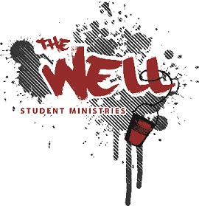
Girly Weekend
Date: March 20-21, 2020
Friday, March 20- Meet at 7pm (Eat Dinner before you come)
Saturday, March 21st return to LWCC by 7:30pm

Where: Living Water Community Church/ Hershey E Free Church
Who: All 8th -12th Grade Girls
What to expect: Girly weekend is a year opportunity for the girls of “The Well” to gather in fellowship and learn how God has made them. This year we will be join Hershey Evangelical Free Church and taking part in their Confidence Conference. This annual conference is jam-packed with worship, teaching and breakout sessions for girls to realize their value in Christ and how to live with a passion for Him! We pray that each girl is brought to the conference intentionally by God and that they learn lifelong, valuable lessons from the gospel about God’s amazing plan for their beautiful lives!
Cost- $25
How to Register: March 15th Deadline-Go online to Livingwatercc.com and Submit $25.
2020 Liability Waiver for The Well will be sent to you and are to be completed prior to the trip.
What to Bring:
Bedding – Sleeping Bag, Pillow
Clothes
Any personal items needed for the night
MOST IMPORTANTLY: Bible, Notebook and Pen (bring a string bag or small bag to carry during the conference)

Friday
7pm- Check-in and Baking
8:30pm- Games (Leader Food Wars)
9:30pm- Movie
Get some sleep after the movie!

Saturday
7:15am- Breakfast
8:15am- Leave for Conference
9am Conference Start
Lunch will be at the conference
5:45 Conference Ends
6:30 Dinner
7:30 Return to LWCC

